Yale center for international and area studies

Genocide Studies Program

Yale East Timor Project

2001 Annual Report

Convenor: Ben Kiernan,
Director, Genocide Studies Program

Contents

‘Conflict Resolution and East Timor’: President Xanana Gusmao
Address at Yale University, April 2, 2001

Report of Yale’s Mission to East Timor, March 2001 Bishop Paul Moore, Jr.

The Genocide Studies Program (GSP) Human Rights Documentation Jessica Thorpe and
Training Project Nereida Cross

Yale Law School Activities in East Timor, 2001 Jamie O’Connell

Report to the Yale School of Medicine on Health Care in East Timor Fredric Finkelstein, MD
and Susan Finkelstein

Treating Child Illness in Dili Angela Rogers, MPH

The Griffin Center for Health and Human Rights in East Timor Joanne Cossitt and
Ramin Ahmadi, MD

East Timor’s Natural Resources and Policies: A Reconnnaissance Report Steve Rhee, Timothy Clark, and Michael Dove

GSP Training Manual in Bahasa Indonesia for East Timor Human Rights Documentation

CONFLICT RESOLUTION and EAST TIMOR

President Xanana Gusmao,
National Council of Timorese Resistance

Genocide Studies Program public lecture, Yale University, April 2, 2001

Excellencies, distinguished scholars, ladies and gentlemen.

The challenge of creating a just society in East Timor and bringing peace and harmony to our citizens raises very complex issues.

The fundamental issue confronting the East Timorese nation as it emerges from many years of oppression is the establishment of a stable socio-economic base. Unless the people have the basic means of survival initiatives such as conflict resolution may be perceived as a wrong priority.

The almost total destruction of basic infrastructure by the retreating TNI and it’s sponsored Militia left a great number of Timorese without a roof to sleep under. To speak of reconciliation is to emphasise the destruction. How can we have understanding and effective participation before the damage is repaired and economic life restored? How can we call people to a conference on Conflict Resolution when the symbols of violence and the grief of 25 years are on every person’s face?

Against this background it is better to speak of Post-Conflict Resolution because the situation of Timor is unique. Conflict Resolution in other international contexts is an initiative in an ordered society with specific conflicts. In Timor the people have survived anarchy -we are starting from ground zero.

In this vacuum the minimum conditions for implementation of Conflict Resolution are safety for the participants and basic socio-economic security. These are the pre-conditions for any community based conflict resolution programme.

In the middle of all our civil society problems it is unrealistic to say we can develop a model justice system in East Timor. We need a new formula to bring justice in a way acceptable to all the people.

In dealing with those who were dragged into the communal violence of August-September 1999 we may have to redefine justice in terms of Timorese tradition and our physical capacity to impose sanctions. Traditional methods of post- conflict resolution such as public confession and apology have already worked in some village situations. These processes need to be facilitated and strengthened. In this context East Timorese facilitators need resources and training. Internationally recognised programmes such as those established by Columbia University’s International Conflict Resolution Centre are in the process of implementation but there is recognition that economic initiatives must accompany conflict resolution.

Going alongside these local dispute resolution initiatives is the need for national healing and this requires the identification of the principal perpetrators. I accept that special processes must be followed to bring to trial those who planned and directed the years of genocide in my beloved country. Many Timorese want answers from those who caused their loss and suffering. With answers people can start the healing process and close the horrible chapter in their lives. This is an international responsibility that goes beyond the events of August/September 1999.

The task will be very distressing for the Timorese but it must be started for it will take many sad years. The crimes of the invader were crimes against humanity for which the Generals active and retired and their puppets must be held accountable. While this may strengthen the democratic process in Indonesia the primary intention must be to shine light where there is darkness. Such terrible events must never happen again and true documented history is our reminder of human cruelty-it is the lighthouse that forever flashes a warning to our succeeding generations.

I was pleased yesterday to be introduced to Yale’s East Timor Documentation Project covering the events of 1975 to 1999.

Professors Ben Kiernan and John Taylor are well qualified to bring the dispassionate mind of the historian to an immensely important project. Training East Timorese in this work will bring the intellectual standards of a great University to our capacity building.

In allowing ordinary Timorese to tell of their suffering and courage your project will meet a social need for so many of my people to know the world did care and will now listen to their terrible private history.

In listening to the stories you must let the tears flow for they will wash away the ashes of our past to reveal a bright shining future for my people. But that future requires a solid social justice plan.

Peace in Timor will not just come about with the investigation and punishment of wrong-doing. Peace is about the implementation of social justice for the whole population whether or not some voted for or against independence. Peace is also about the needs of the victims and recognition that community conflict has in many cases been based on disputes originating in earlier times-family arguments, disputes over property, competition between villages for resources are some examples.

I am conscious that the oral and documentary history of events affecting the East Timorese people throughout the 20th Century-especially the 1975-1999 occupation period is yet to be compiled. My words today are structured around my insights into the history of reconciliation and conflict resolution among East Timorese and between East Timorese and other international parties.

Much of the Timorese struggle has to be viewed against the actions of the other actors particularly the Government of Indonesia. World attention to the struggle accelerated after the massacre at Santa Cruz on 12 November 1991 and between 1992 and 1998 friendly countries pushed for increased United Nations involvement.

The clandestine movement in East Timor strengthened with the help of true friends abroad increased its exposure of events in East Timor. With practical help from Portugal representatives from the entire Timorese Resistance in the diaspora together with some courageous participants from inside Timor came together at Peniche in Portugal over an historic week in April 1998. My message then from imprisonment (as it is now in happier family time) is that unity is strength. The Conference unanimously resolved to put away political differences and to unite with one voice as the National Council of Timorese Resistance (CNRT). The conference named me as President of the CNRT and Jose Ramos Horta as Vice-President.

Following meetings in Vienna, the dialogue at Dare and a National Planning Conference at Melbourne a plan for Reunification, Reconstruction and Normalisation was developed for a free East Timor but some key countries fearing the breakup of Indonesia or like Australia just fearing Indonesia would not go further than supporting autonomy for Timor within the Indonesian State.

In 1999 the situation moved rapidly leading to The Agreement between Indonesia and Portugal on The Question of East Timor of 5 May 1999 and further agreements between the United Nations and the Governments of Indonesia and Portugal of the same date regarding the modalities for the popular consultation of the East Timorese through a direct ballot and for security arrangements.

Ironically, it was the 5 May 1999 agreements agreed to by President Habbie of Indonesia that now appear to have resulted in an organised, subversive and criminal reaction against the accord by elements of the TNI.

The chaos that emerged after the popular consultation arose during a period when for the first time since the invasion in 1975 the world community recognised the central authority of the United Nations and the Indonesian authorities to maintain peace. In this sense the international community supporting the ballot had a special responsibility to protect the East Timorese who were encouraged to participate openly in the ballot. The courage of the unarmed UNAMET staff in that period deserves special mention. The question remains whether the ballot should have been conducted under stronger UN security.

Future investigations into the terrible events of August/September 1999 must necessarily focus on the duty of care the sponsoring nations had to my people in that period. There are claims apparently documented that the TNI had detailed plans to commence the destruction if the outcome of the ballot was for independence. The question whether any sponsoring nation had knowledge of the plans and failed to warn the world community must not remain unanswered.

For the next few months peace only came at the point of a gun and the Timorese people endured great suffering. No dialogue of any kind was resumed until the United Nations Transitional Administration (UNTAET) was established pursuant to Security Council Resolution 1272 adopted by the Security Council at its meeting on 25 October 1999. The CNRT set up early post-conflict resolution talks in towns and villages where there were disagreements within and between communities over such issues as property ownership and claims of militia membership.

As I have said the lessons to be learned from the lawless vacuum that emerged during and after the public consultation is for another study. That period was marked by the total loss of dialogue between the dissident elements – total anarchy replaced the very difficult and at times shaky agreements negotiated from time to time between the parties from 1975 onwards. For example, the 1983 ceasefire.

The absence during the post ballot anarchy of some natural law of reason is a stark reminder of the necessity to ensure that barbarian tactics never find fertile ground again in our beloved Timor.

Timor went back in the European sense to the Dark Age of barbarism. Francisco Suarez a Spanish jurist-theologian who in the 16th Century spent many years at the Portuguese University of Coimbra said that international law presupposes a community of all mankind, united by the natural precepts of mutual love and tolerance. This is true to this day as we seek to normalise relations with Indonesia whose people at large we do not blame for the terror that befell our people.

A system of conflict resolution is not new to the East Timorese people – we have been negotiating by necessity often under duress for several hundred years!

During all of the offensives conducted by our glorious Falintil there was an element of reason on both sides. Agreements were extracted sometimes by persuasion and sometimes by necessity for survival but they were agreements, they were cease fires, they did allow for survival but the terror of the post ballot period was complete. It was a methodical and non- negotiable attempt to destroy a society.

The planned destruction of infrastructure and the fundamentally immoral destruction of schools, hospitals and libraries marked the blackest period in our peoples’ history.

Against that background conflict resolution machinery is an imperative for the future stability of a society distracted by grief and divided by the anger of many years of oppression.

In this context violence within East Timorese society particularly domestic violence has to be viewed as the outcome of historic patterns of conflict. The national characteristics of the East Timorese particularly their sense of family, their generosity and overwhelming Christianity will be the medium by which an orderly transition to a society which resolves conflict by negotiation, mediation and compromise. This transition will require careful empowerment of community elements, particularly women and youth, and, effective capacity building by international agencies.

Conflict resolution for the modern state of Timor involves an acceptance of peaceful dialogue as the appropriate means of achieving personal objectives. As I said at the beginning unless the people have a proper living standard they will be too busy concentrating on economic survival to spend time thinking about loving their neighbour.

The various Security Council Resolutions relating to Timor, particularly 1264/1999,1272/2000,and 1338/2000 oblige UNTAET to maintain orderly government in the territory of East Timor until independence and to advance society to democratic level. The UNTAET role is only part of the world community’s obligation to help the Timorese people.

All States have a general duty to assist an emerging state both by joining in the protection of ethnic, religious and cultural minorities for example, and in seeing that the universal values are recognised. The view is accepted that those universal values include the obligation on the part of the richer states to provide assistance to poorer states in situations where poorer states are prevented by lack of resources from fulfilling their own obligations to their citizens. Acting on that precept Donor States have pledged hundreds of millions of dollars. International public servants should not overlook the moral imperative for their work, namely, the advancement with all practical urgency of the welfare of the Timorese people.

In conclusion I should emphasise that Conflict Resolution initiatives must be inter-related with international co-operation to eliminate poverty and international co-operation in solving the economic, social and other humanitarian challenges facing East Timor.

I am pleased to say that the Genocide Studies Program of Yale and the International Conflict Resolution Centre at Colombia are but two of the resources from which East Timorese people can draw in meeting the challenge ahead.

Kirsty and I thank you for your invitation here. We have met old and new friends in the discussion of the issues around international repatriation, documentation, mediation and conflict resolution. I hope we can give you positive messages when we next meet.

KAY RALA XANANA GUSMAO

REPORT OF YALE’S MISSION TO EAST TIMOR, March 2001
Bishop Paul Moore, Jr.

On March 8, 2001, a delegation from Yale University arrived in East Timor to explore ways in which Yale could assist in the rebuilding of that beleaguered, small nation.

Bishop Paul Moore, Jr, a former member of the Yale Corporation and Senior Fellow, together with Mrs. Brenda Moore, had visited East Timor in 1989. The land was still under military occupation by the Indonesian army and Jakarta had only recently allowed anyone to visit. In 1975, after the Portuguese had abandoned their colony of four hundred years, President Suharto, with the encouragement of Henry Kissinger, then Secretary of State, and President Ford, invaded East Timor and slaughtered over 100,000 persons. Weapons from the United States were used, although furnished to Indonesia with the understanding they would be used only for defensive purposes. Up to another 100,000 persons were estimated to have died in the years following the invasion.

The first person the Moores visited, was Mgr. Carlos Ximenes Belo, the young newly-appointed bishop of East Timor. He was in a state of siege and felt he might be assassinated any day. Some twenty young people were living in his compound for fear of the police. We quickly learned of the brutality of the occupation. Soldiers on the street corners, rooms bugged, houses broken into, men “disappeared”, young men tortured and imprisoned without trial. Bishop Belo stood out against these abuses with great courage and at the same time attempted to keep the young people from taking actions which would endanger them.

In 1998, at Bishop Moore’s suggestion, Belo was awarded an Honorary Degree by Yale University. Dean Richard Wood of the Yale Divinity School met him over Commencement, and we planned another visit to East Timor with the Dean. On the return from the trip, the Yale East Timor Committee was established under the chairmanship of Dean Wood.

Before we could think through how Yale could be of assistance, given the extreme repression and control of the occupation, Indonesia’s President Suharto was ousted and succeeded by Vice-President Habibie, who authorized a referendum on independence. 90% of the population came to the polls, despite the danger, and of those voting, some 78% voted for independence. The Indonesian military and their militia lashed out in rage, because East Timor had been their fiefdom for military maneuvers. The military also took profits from the coffee plantations and other ventures. In a few days they destroyed 70% of the buildings in East Timor, massacred thousands, raped hundreds of women, assassinated priests and nuns, and murdered many persons even inside church buildings where they had sought sanctuary.

The international community did not stop the mayhem in time, but, after a few weeks, the United Nations did intervene and now is in charge until such a time as the East Timorese are in a position to be independent, hopefully in a year or two.

The needs there are overwhelming, since, under Indonesia, very few Timorese were educated. For instance, there are only twenty-two doctors and fifty lawyers for a population of 700,000. Our delegation, under the chairmanship of Prof. Ben Kiernan, now Convenor of the Yale East Timor Project, and Bishop Moore, included nephrologist Prof. Fredric Finkelstein and Susan Finkelstein, a psychiatric social worker, of the Yale Medical School, Dr. Ramin Ahmadi and his assistant for Human Rights, Ms. Joanne Cossitt of Griffin Hospital, an affiliate of the Medical School, Ms. Kimberley Pattillo and Jamie O’Connell representing the Orville H. Shell, Jr. Center for International Human Rights at the Yale Law School, Mr. Steve Rhee of the Yale Forestry School, and Mr. Arnold Kohen of Washington, DC, the biographer of Bishop Belo and an expert on East Timor.

UN Secretary-General Kofi Annan hosted the delegation at a luncheon with his staff at the UN before we left, and furnished us introductions to the Honorable Sergio di Mello, head of the United Nations Transitional Administration in East Timor (UNTAET). On our arrival in Dili, Mr. di Mello welcomed us, made his staff available, and furnished us with a bus. Dr. Ahmadi and Ms. Cossitt had been to East Timor several times, as had Mr. Kohen and Bishop Moore. Prof. Kiernan had first visited the territory in 1972. We thus knew the East Timorese leadership as well.

The delegation, individually and as a group, met with at least 100 people in Dili, the capital, as well as many others elsewhere in the country. We interviewed Xanana Gusmao, former resistance leader and prisoner in Indonesia and the presumed future president. We were given a dinner by Bishop Belo, met with the head of the East Timor Security Forces, the Financial Officer for the local government, the Human Rights Commissioner, several Jesuit priests and Maryknoll clergy, and countless others.

I believe this Project embodies the best of Yale’s tradition and enhances President Richard Levin’s emphasis on the University’s internationalization. The experience will, I hope, assist the East Timorese but also will be an invaluable educational experience for the faculty and student participants.

THE GSP HUMAN RIGHTS DOCUMENTATION TRAINING PROJECT IN EAST TIMOR

Jessica Thorpe,
for the Genocide Studies Program

Summary

During July and August 2001 we were able to support efforts underway in East Timor to document the genocide which took place during the Indonesian occupation of 1975-1999. This was possible thanks to funds made available by the Genocide Studies Program, the Jocarno Fund, the Open Society Institute of the Soros Foundation, the Australian branch of the International Commission of Jurists, the Yale Council on Southeast Asia Studies, the Coca-Cola World Fund, and the Schell Center for
International Human Rights at the Yale Law School, and the assistance of Ms. Nereida Cross of the University of New South Wales and of Mr. Rui Gomes of Southbank University.

With the help of Rui Gomes, who is competent in Portuguese, Bahasa Indonesia, Tetun and English, we developed a series of human rights database manuals in Bahasa for training East Timorese from various non-government organizations (NGOs) in Microsoft Access, Foxpro and Excel. The manuals
we developed were tailor-made for the organizations in East Timor to meet their specific needs in tracking human rights violations. The trainees included 8 people from the Commission for Human Rights in East Timor (CDHTL), 6 people from the Timorese women's NGO Fokupers, 3 from Yayasan
Hak, 2 from ETWAVE, 5 from the Commission for Peace and Justice, and 4 from East Timor's NGO Forum.

In Dili, we also trained 2 staff from the UN's Serious Crimes Investigation Unit (SCUI) to use their Lotus Notes DocTrack system, as well as other staff from the Prosecutor's office in Excel. Nereida Cross conducted a week of training in the database platform WinISIS for two staff from the Library of the University of Timor Lorosa'e. The total of around 34 people who were given database training in Dili and Baucau was more than double the number we had expected to work with.

Project Preparation

In preparation for the project, I worked with Yale's Cambodian Genocide Program and Mr. John Bullock, from whom I obtained the teaching plans and manual he had used in 2000 during the GSP/CGP project to train two Rwandan students in the use of Access. In May 2001, I went to the University of New South Wales in Sydney where I spent 2 weeks studying WinISIS with
Nereida Cross, and consulted with specialist Access trainers from Sydney's WEA on developing the appropriate training manuals. Then in London, I worked with Mr. Rui Gomes to contact our prospective trainees, the NGOs, and the University. At this time, we also sought to identify potential problems likely to be encountered in East Timor, particularly pertaining to security threats, and other obstacles during the upcoming busy election period, as well as trainees' expectations and
their potential lack of computer experience.

Implementation

The extent to which we were able to prepare the project in advance was limited, as a database is likely to be more useful if the fields are defined by the various end-users (rather than emulating the embryonic Rwandan Genocide Project model by developing different fields in Access
for the East Timorese setting). This was obvious on the basis of the needs assessment we did upon arrival in East Timor. Thus, we focused our efforts in East Timor on helping trainees organize and manage the vast amounts of information their organizations had collected into a database.

The database platform chosen tended to reflect what was already being used in each organization, as in the NGO Fokupers where they used Access. In NGOs which had no platform up and running, we chose Foxpro. This was a platform which database specialist Ken Ward of the UN's Human Rights
Unit had already set up for the Unit (as well as for projects in Cambodia, Sri Lanka and Guatemala). This Unit had a mandate to support NGOs and was keen to work in partnership; so we would develop manuals for their system and they could provide follow-up training through September and October 2001 after our departure.

Teaching in one classroom was not feasible as the trainees all had different needs and we could not provide enough computers for the kind of hands-on training which was required. We decided the best way to offer constructive training was to teach on-site. Often, however, we were frustrated by problems with computers in their offices, notably the rampant viruses and problems associated with the hot climate and power surges. The platform crashing midway through a class would not help
convince our trainees of the benefits of using a database! We were also sometimes frustrated with the lack of coordination and internal communication we encountered as well as unreliability, the high staff
turnover and problems of retaining institutional knowledge.

Conclusion

As well as working with NGOs, we devoted a large amount of time to helping trainees responsible for the database in Serious Crimes develop an understanding of documenting human rights violations. It is envisaged that this database will be further developed under UNTAET (United Nations Transitional Administration of East Tmor) and handed over to the East Timorese Prosecutor's Office to continue the establishment of the rule of law, and accountability for crimes against humanity. We encouraged NGOs to push the transitional administration for justice and accountability in these serious crimes cases.

While the approach we took required greater effort on our part, primarily in terms of the additional labor to develop a new manual for every group we trained and to relocate to their offices, we were pleased with the results.

Appendix

TRAINING ON THE EAST TIMOR HUMAN RIGHTS DOCUMENTATION PROJECT DATABASES

Nereida Cross,
University of New South Wales

Training in East Timor Human Rights Violations Database -- Bibliographic (TBIB)
6th August to 10th August - Biblioteca Universidade Nacional Timor Loro Sa’e (Library of the National University of East Timor), Dili.

This training course was made available through the Yale East Timor Project. I would also like to thank the Australian Section, International Commission of Jurists.

This training program involved:

- installing UNESCO’s CDS/ISIS for Windows and providing training in this software

- creating bibliographic records for TBIB using the Input Manual developed for this database - East Timor Human Rights Documentation Project Databases INPUT MANUAL / developed for the Australian Section of the International Commission of Jurists by Nereida Cross and Helen Jarvis, September 1999

- inputting the records using an online TBIB data entry worksheet. The worksheet is now available in English and Indonesian

- searching, displaying and printing of TBIB database records

Participants:
Adelino Ameta and Celeste Soares, Biblioteca Universidade Nacional Timor Loro Sa’e; and Rui Gomes, Yale East Timor Project. Rui Gomes was the translator for the training course.

Training Program

Monday Introduction to CDS/ISIS for Windows. Demonstration of the different language menus including Portuguese. Searching module using a variety of CDS/ISIS databases: Cambodian Genocide Program Bibliographic Database (CBIB), East Timor Human Rights Violations Database -- Bibliographic (TBIB), Porb (a sample Portuguese language database from the National Library of Portugal), Database Teknologi Tepat Guna (an Indonesian language database from Pusat Dokumentasi dan Informasi Ilmiah, Indonesia).

Tuesday Database structure for TBIB. Underlying structure – records, fields, subfields, MARC (Machine Readable Cataloguing). Data entry exercises and record printing.

Wednesday Cataloguing. Using the TBIB database manual to catalogue items onto TBIB worksheets.

Thursday Data entry into TBIB from the worksheets and directly into the database using the data entry module and books from the Library’s collection. Also looked at database modification, particularly how to change the online data entry worksheet to cater for other languages eg Indonesian, Tetum. We looked at how to add or change Help messages in the data entry worksheet.

Friday More data entry. Importing and exporting TBIB records. Creating and changing display formats in CDS/ISIS for Windows, and with the Sort feature producing different styles of output. Practised installing the CDS/ISIS software. We also looked at a demo CD-Rom for Porbase version5, from the National Library of Portugal, which has cataloguing, acquisitions, searching and web interfaces suitable for libraries with a CDS/ISIS for Windows database.

The Library now holds a set of CDS/ISIS for Windows reference manuals in English, Indonesian and Portuguese; and the CDS/ISIS installation disk.

Related activities 6th August - 11th August
The UN Serious Crimes Unit and the Human Rights Unit both already had databases to manage cases, as did Fokupers (Forum Komunikasi Untuk Perempuan Loro Sae – Communication Forum for Women from the East). The Human Rights Unit is using the database software FoxPro; Ken Ward, who is under contract till the end of the year, designed it. When Jessica arrived one of the first organizations that said they wanted training was CDHTL (Commissao dos Direitos Humanos de Timor Leste). For this type of database, as opposed to the bibliographic one above, it was decided to use the same software as the Human Rights Unit, and the database was tailored to the meet the needs of CDHTL - an opening screen with its own title and a customised data structure with fields reflecting the information collected. It is in two languages with Indonesian & English menus. I attended a training session on the 11th August. I think that the UNSW should try and obtain a copy of the standard FoxPro database from Ken too, so that consistency is maintained for this type of data if we were to continue with our project here.

Fokupers already had an Access database set up to record their cases. It had been designed by Susana Barnes from the Jesuit Refugee Service. The main person who input records into the database was about to leave for Portugal to complete her law degree. There was no database manual, so Jessica offered to write one and Rui was translating it into Indonesian. They decided on two manuals, one for data entry and another for users to encourage others in the organization to use the database more. I visited Fokupers on 6th August and was given a demonstration of their database.

Apart from Fokupers and CDHTL, during my stay we were also in contact with ETWave (East Timorese Women against Violence) and Yayasan Hak. Jessica arranged for both organizations to be given training in FoxPro on the following Saturday afternoons. I visited and attended a meeting with Yayasan Hak. After I left, Rui worked with Yayasan Hak on requested CDS/ISIS for Windows training.

Nereida Cross
September 2001

YALE LAW SCHOOL ACTIVITIES IN EAST TIMOR, 2001

Jamie O’Connell
for the Orville H. Schell, Jr. Center for International Human Rights

Yale Law School’s work on East Timor has been under the auspices of its human rights programs, supervised by James Silk, executive director of the Law School’s Orville H. Schell, Jr. Center for International Human Rights, and Deena Hurwitz, the Cover-Lowenstein Fellow in International Human Rights Law. The work has taken two forms so far: funding Yale Law student Jamie O’Connell’s and Yale International Relations student Jessica Thorpe’s work in East Timor during the summer of 2001, and organizing research support by a team of Yale Law students for the Human Rights Unit of the United Nations Transitional Administration in East Timor (UNTAET).

Jamie worked in the National Office of Civic Education. The Office was, in essence, the staff of the National Steering Committee on Civic Education. The all-Timorese NSCCE consisted of the Catholic Church, the University of East Timor, the Department of Education, and four NGOs, Rede Feto (Women’s Network), the Student Solidarity Council, NGO Forum, and the Association of Veterans (formerly National Council of Timorese Resistance). The national civic education program directed by the NSCCE and administered by the National Office facilitated the growth of democratic values and behavior, and disseminated information on the elections of August 30, 2001. It involved trainings and briefings by teams based in all 13 districts, consisting of East Timorese trainers supported by international staff; production and distribution of civic education materials; a series of public events; and financial support for grassroots projects conducted by East Timorese civil society organizations. The program received financial support from the United Nations Transitional Administration in East Timor and the United Nations Development Program. Jamie worked closely with the civic education program’s director, Colin Stewart. His responsibilities included providing ongoing feedback on the program’s effectiveness and internal functioning, and producing information on the civic education program for consumption by other UN offices and the media.

Yale Law School’s work on East Timor is continuing in the fall 2001 semester with a project of the Allard K. Lowenstein International Human Rights Clinic, which is associated with the Schell Center. A team of Yale Law students enrolled in the Clinic is providing research support on international law issues to the UNTAET Human Rights Unit.

These activities all grew from discussions held by Jamie, Yale Law student Kimberley Pattillo, and Yale East Timor Project convenor Ben Kiernan, when they visited East Timor in March 2001 as part of a Project delegation.

Schell Center summer funding will make it possible for Yale students to do human rights work in East Timor again next summer. As always, this will depend on the fit between individual students’ interests and skills and the needs of the UN and international and East Timorese NGOs.

REPORT TO THE YALE SCHOOL OF MEDICINE ON HEALTH CARE IN EAST TIMOR

Fredric O. Finkelstein, M.D.
Susan H. Finkelstein, MSW.

We visited East Timor as members of the Yale delegation to East Timor in March 2001. We are members of the Departments of Medicine and Psychiatry at the Medical School and were looking at health care delivery in East Timor to see how the Medical School could provide assistance to the country in terms of health care delivery or educational support. During our stay, we visited several health care facilities and discussed at length the problems of health care delivery with the current United Nations personnel in charge of health care in East Timor, some of the East Timorese who will be assuming leadership roles as the UN withdraws, and various physicians, administrators and other personnel currently involved in health care delivery in East Timor. The following summarizes our impressions and recommendations for future opportunities for Yale to provide assistance.

BASIC FACTS ON EAST TIMOR HEALTH CARE - 1

Under the Indonesian Administration, Health Care in East Timor was poorly run
a) East Timorese were, to a large extent, denied active participation in the Health Care System

b) Life expectancy in East Timor was 48 years (compared to 66 in Indonesia)

c) Infant mortality rates were 135 per 1000 live births

d) Overall health care planning was poorly organized

BASIC FACTS ON EAST TIMOR HEALTH CARE - 2

- During the struggle for independence, 35% of health care centers were totally destroyed or severely damaged; the remaining 65% had various degrees of damage, but were potentially reparable

- 67% of the medical equipment was destroyed or looted during the Indonesian withdrawal

HUMAN RESOURCES FOR HEALTH CARE DELIVERY

- There are about 22 East Timorese doctors -- 6 are out of the country at present receiving additional training in Australia or New Zealand

- There are about 60 medical students who completed some training in Indonesia. Two are now at Griffin Hospital in Derby, Connecticut, completing their training. The official policy of the UN Health Care Agency is that the partially trained students should return to Indonesia to complete their training, despite threats issued to these students.
- There are about 400 East Timorese nurses; 11 of these had completed a 3-year diploma course; the remainder, a 3-year high school program

- In terms of international health professionals, there are currently about 40 doctors and 50 nurses working in East Timor

- The Interim Health Authority is currently trying to coordinate health care in East Timor

- Educational resources: The educational system is East Timor is completely disrupted. The University in Dili is just starting to function; there is no medical, nursing, or public health school.

CURRENT ORGANIZATION OF THE INTERIM HEALTH AUTHORITY (IHA)

- The IHA is composed of 16 Timorese and 9 International health professionals

- The goals are to work with the various NGOs, UN agencies and East Timorese to:

- rebuild and rehabilitate health care facilities
- train and support East Timorese health personnel
- ensure an adequate supply of drugs via a central pharmacy for the country
- maintain a communicable disease surveillance system
- develop a well-coordinated health care system

- Current head of the IHA is a WHO official -- the aim is to transfer leadership to the East Timorese by the end of the year 2001

GOALS OF THE IHA FOR THE FUTURE

To develop a health care system based on levels of service. These include:

- Level 1: mobile clinic and village health post -- staffed by nurses and mid-wives

- Level 2: community health center -- no in-patient beds -- focus on out-patient care -- located in each of 64 health care districts

- Level 3: community health center with 5-10 in-patient beds; located in each of 8 district capitals

- Level 4: tertiary hospital -- 5 hospitals (down from the current 8) to be staffed with physicians provided by NGOs working with East Timorese doctors. Specialty services to be provided by teams of foreign health care providers (e.g. ophthalmology and plastic surgery teams to fly in from Australia at fixed intervals)

FOCUS OF HEALTH CARE INITIATIVES

- Child health -- immunizations, basic care

- Reproductive health -- issues of family planning present problems with the Catholic Church
- Communicable diseases:
- malaria: over 100,000 cases diagnosed per year (according to UNTAET), one of the leading causes of death
- tuberculosis: estimates are that between 15-25,000 East Timorese are infected with TB; less than 1,000 people are being treated
- Dengue fever: is endemic in East Timor; hemorrhagic dengue fever is not common but present
- Japanese encephalitis: endemic in East Timor; high mortality rate for those with active infection
- HIV: no estimates of prevalence; Dr. Ramin Ahmadi is proposing a study to look at this question this summer

EXAMPLES OF NGO INITIATIVES

- Dr. Dan Murphy: runs a remarkable clinic in downtown Dili; receives no government or UN support; has a small in-patient facility; refers patients requiring hospitalization to the ICRC Hospital; sees 100-200 patients per day

- ICRC Hospital: 210 beds, 7000 admissions/year, 3000 surgical cases; internal medical service is currently run by two Columbia/Cornell doctors who just completed their residency; they are leaving in the fall and will be replaced by Dutch physicians provided by CORDAID

- Medecins du Monde: runs primarily out-patient facilities in Dili and Suai; are actively training village health care workers with a well-coordinated curriculum; bring the village workers to their facilities for brief stays and intensive training

- New Zealand Army Base at Suai: provides the most sophisticated level of health care (that we observed) in East Timor out of a field hospital (excellent in-hospital facilities, operating room, lab support); e.g. surgery for ruptured appendix, C-section; 2 children with TB meningitis

- Fokupers and ETWave, run by East Timorese and supported by NGO funding, provide support, counseling, and shelters for victims of trauma and domestic violence; Fokupers focuses on the empowerment and support of women; one of the ETWave shelters is called Kofi-1, and was a gift of Kofi Annan

MENTAL HEALTH ISSUES AND SERVICES

Mental health issues are of major importance given the recent traumas that the East Timorese have sustained. However, the issues are not being addressed in a systematic way.

- There is no existing plan to provide mental health care.

- A recent study of Ramin Ahmadi (JAMA, in press) documents a high incidence of PTSD and depressive symptomatology in East Timorese.

- There is widespread domestic violence, especially spousal abuse. Women are particularly vulnerable in this society -- they marry young, the husband's family pays a dowry, and thus she is considered the "property" of the husband.

- There are few reproductive health services -- this reflects in part the influence of the Catholic Church.

- Men, who have fought for years for independence, have not been adequately educated with learning or technical skills for work. Their history in the struggle for independence makes violent behavior more likely.

SUMMARY AND CONCLUSIONS

The development of an effective health care system in East Timor requires that the following issues be addressed:

- coordination of various health care programs -- the NGOs, Department of Health, United Nations -- via a strong central Department of Health
- complete the basic training of the East Timorese medical students who have completed some training
- develop longterm educational goals for the country, in terms of strategies to train physicians, nurses, para-medical personnel
- development of programs to train village health care workers
- development of basic strategies to provide immunizations; treat endemic diseases, such as TB, malaria, etc.
- maintain channels of communication with tertiary care centers and academic institutions outside of East Timor
- organize and provide the health care in the context of
- the recent traumas of the East Timorese
- understanding the local, traditional channels of authority -- village leaders, shamans, etc.
- recognizing the economic constraints placed on the country by the lack of basic industry, business, etc.

We think that the areas cited above that require planning and attention represent possible opportunities for Yale to provide assistance to East Timor.

Fredric O. Finkelstein, M.D.
` Clinical Professor of Medicine
Yale University

Susan H. Finkelstein, MSW
Assistant Professor of Social Work in Psychiatry
Yale University

TREATING CHILD ILLNESS IN DILI

Angela Rogers, MPH

Background
During the rampage of violence and destruction following the August 1999 referendum for independence from Indonesia, the Indonesian militia damaged 77% of health facilities, and looted or destroyed 67% of the medical equipment. Indonesian doctors and health workers had left East Timor just prior to the referendum, leaving only 35 East Timorese doctors in the country. In addition to a severe shortage of trained health workers, the country faced the aftermath of massive displacement of the majority of the population (75%), which occurred after the independence referendum. Conflict, displacement, and gross human rights violations have only exacerbated the already poor health status of the East Timorese.

East Timor faces a multitude of major health challenges, including acute respiratory infections, diarrhoeal diseases, malaria, dengue fever, malnutrition, and tuberculosis. WHO has identified treatment of common childhood diseases (diarrhea, malaria, and acute respiratory infections) as among the highest priority of current health issues for East Timor. Reconstructing the health infrastructure in East Timor is an immense endeavor, and at present no systematic assessment of the health and nutritional status of the East Timorese population has been performed. WHO states, “Although health statistics are available from prior to the referendum, the environmental, economic and personal health conditional are now very different than they were in the past.”

It is recognized that traditional medicine is part of Timorese culture, and has been in existence since before the Portuguese colonization. However, despite the widespread use of traditional medicine, virtually no research exists on the subject. It is difficult to estimate either the positive or negative impacts traditional medicine might have in East Timor, because of the sparse knowledge of the relationship between traditional and western medicine.

Purpose of Study
Parents and caregivers are faced with many choices in treating a child’s illness – whom to ask for advice, what treatments to use at home, whether to use traditional or Western medicine, and when to take their child to see a doctor/nurse or to a traditional healer. The specific aim of this research project was to examine the treatment of child illness in Dili through informal interviews as well as a household questionnaire designed to gather information on home treatment and care practices, use of traditional medicine, use of clinics and traditional healers, and factors influencing seeking care from health providers. This research project was conducted in Dili, East Timor during June-August 2001 in coordination with Bairo Pite Clinic. Funding for this project came from the Down’s International Travel Fellowship at Yale University, and the Office of Student Research at Yale University School of Medicine.

Research Methods
The questionnaire used for this study was compiled from questions used in previous questionnaires in developing countries, as well as original questions. The questionnaire was translated into both Tetum and Bahasa Indonesia by native speakers, backtranslated into English, and field tested. Six East Timorese workers from Bairo Pite Clinic were trained to administer the questionnaire. The questionnaire was administered in Dili between July 11, 2001 – July 16, 2001 to 360 households using a random-walk method within selected cluster samples. Informed consent was received from all participants. In addition to data collected from the questionnaire, informal interviews were conducted with traditional healers, health workers, and the lay public to gather more qualitative data. The questionnaire was approved by the Human Subjects Research Review Committee at Yale University School of Nursing. In addition, this research project was approved by Dr. Dan Murphy of Bairo Pite Clinic.

Results
Informants were asked to describe the child’s illness, and to list up to three symptoms/ health problems the child had in the previous thirty days. The average number of symptoms reported was 2.8. The five most common symptoms reported include: cough (69.0% of children), runny nose (47.2%), fever (44.9%), diarrhea (21.3%), and fever with chills (15.3%).

The general pattern of treatment over the course of the illness is to first give treatment at home (including traditional medicine, Western medicine, and comfort measures), then take the child to a doctor/nurse if the child does not improve. If the child still does not improve after seeing a doctor/nurse, then the child is generally taken to see a traditional healer. Over the course of the child’s illness, most caregivers consulted at least one other person (usually their spouse or their mother) about the child’s illness.

A majority (66.5%) of informants gave their child at least one treatment before seeking additional care from a health provider. Of those who first gave a home treatment before seeking further care, an average of 2.13 treatments per child were used. Of those children who received at least one home treatment, the most common home treatments given include rubbing coconut oil on the child’s body (38.5%), rubbing a mixture of coconut oil and onions on the child’s body (28.6%), compress (25.2%), medicine bought from the market/store (20.9%), and Oral Rehydradtion Salts (ORS) - including both store bought and homemade (15.4%). See Figure 1 below for a full listing of home treatments used.

It is of interest that 13.9% of all respondents (20.9% of respondents who used at least one home treatment) gave their child medicine which had been purchased from the market or store. Informants were not asked what medicine was given, but a full range of medicines from aspirin to antibiotics and analgesics are sold in the market. There are no regulations on the medicines sold – some medicines are expired, others may be unsafe for children.

A total of 14.7% of all children (22.2% of children who were given at least one home treatment) were given traditional medicine that consisted of using the leaves/bark/milk of trees or plants. Informal interviews support the theory that there is, on the whole, a broad level of knowledge of traditional medicine and its uses within the general population.

*Other treatments primarily include other uses of leaves/herbs and steam bath

Another primary area of interest in this study was to determine to which providers caregivers take their child when ill, the reasons why, and the sequence of providers if multiple providers were seen during the course of the child’s illness. Nearly all informants (95.7%) reported that the first provider they took their child to see was a doctor/nurse. Common responses for why caregiver took their child to the doctor/nurse instead of someone else include the doctor knows all about medicine, illness and how to treat sick children; the doctor is good/best; we believe in the doctor; we always go to the doctor; to get medicine; the doctor gives good medicine.

Twenty-eight informants (8%) who took their child to see a first provider also took their child to see a second provider. Of those who took their child to see a second provider, 89.7% went to a traditional healer. Only 2 informants (7.1%) reported taking their child to see a doctor/nurse as a second provider. Although the numbers of respondents who took their child to see a second provider are small, it is relevant that people were more likely to take their child to see a traditional healer than a doctor/nurse as a second provider. This has particular implications for health clinics wanting to provide follow-up care, especially when the diagnosis may be uncertain due to vague symptoms or lack of investigation.

Informal interviews were conducted with seven traditional healers in Dili. The healers interviewed had much in common, although there is a significant range in their ideology and practice. Some only treated health problems with traditional medicine, others also treated problems believed to be caused by ghosts or someone else’s ill will. Several said that they could also predict the future. Healer treatments generally include use of prayer, candles, traditional medicine (bark, leaves, roots, etc.), coconut oil, and massage. All of the healers have strong religious beliefs and expressed that they are able to get assistance through prayer in order to treat people. From a health planning perspective, there is potential for concern that healers generally do not refer anyone to seek further medical assistance from a doctor or hospital. Healers’ general belief that there are no problems that they cannot treat also has implications for any attempts in the future by the government to work with traditional healers.

Informants listed environmental conditions (child plays in dirt/dirty water, mosquitoes, poor conditions in area) both as reasons why they believed their child became ill, and as problems they face in trying to keep their child healthy. There could be potential to alter the situation through increased environmental health education and awareness. Lack of money and difficulty obtaining transportation were the top two reasons participants gave as their greatest obstacles in keeping their child healthy, and both have potential implications for future utilization rates of health services. Currently, health services provided at clinics and hospitals are free (with the exception of some private clinics), including the medication distributed. It is likely that these problems will only be exacerbated if the government health clinics start charging for services and medicine. As the country rebuilds its health infrastructure, it is critical to consider obstacles caregivers face both in their own sense of control over their child’s health as well as access to services.

Although this study only focused on treatment of child illness in Dili, there are many implications for understanding health-seeking behavior in other areas of East Timor. It is likely that there is a greater use of traditional medicine and traditional healers in rural areas. Informal interviews suggest widespread agreement on greater use of traditional healers in rural areas, as well as a strong cultural history of belief in healers. Access to health care in rural areas is variable – in some villages the nearest health clinic (staffed by nurses) is a three-hour walk. If people encounter difficulties in accessing health clinics, there is the potential that they will instead treat at home or use traditional healers, if they are more accessible. Gathering baseline data in rural areas will be important in understanding treatment of illness as well as tracking changes in the future.

THE GRIFFIN CENTER FOR HEALTH AND HUMAN RIGHTS IN EAST TIMOR

Dr. Ramin Ahmadi, Founder of the Griffin Center and Joanne Cossitt, Director

November 27, 2001

Griffin Center conducted two missions to East Timor in 2001, in January and March. The first was a research team comprised of a nursing student, a public health student, and the director of the center. The team conducted a health survey of the Ainaro subdistrict in coordination with Timor Aid. The team also worked with Dr. Dan Murphy of the Bairo Pite clinic. Also extensive interviews were conducted with NGOs in East Timor, UN officials, and Timorese people.

The second mission was conducted as part of the Yale East Timor Project. Dr. Ramin Ahmadi and Ms. Joanne Cossitt participated in a fact-finding mission funded by the Soros Foundation. The participation in this trip was key in establishing better relationships with cabinet officials. It was also concluded that the country was saturated with international groups interested in short-term involvement in East Timor. Therefore, we felt it was necessary to pursue the idea of a training center that would build capacity on a long-term basis.

During both the January and the March missions multiple human rights associated health issues presented, including the following:

- Lack of adequate health care
Only 23 Timorese doctors (at time of visit 3 were preparing to go abroad for study) for a population of over 800,000; inadequate access to health care, ie location of clinics in relation to villages and distance required to receive care; access to pharmaceutical medications, unless in Dili or Suai, is nearly impossible.

- Nutrition and Food Security
Most people are subsistence farmers (>90%), yet are at risk for malnutrition, vitamin deficiencies, starvation, etc. due to lack of planning; some farmers/villages focus on only a few crops and so are at risk should that crop fail; lack of knowledge of sanitary food preparation/storage, sewage treatment in relation to water supply.

- Violence Associated Human Rights Violations
There are underlying psychiatric morbidities common among the Timorese people (depression %42, Post Traumatic Stress Disorder %7) as a result of the Indonesian occupation; returning refugees, Indonesian integration supporters, and minority populations such as the Muslim community, are at risk for acts of revenge.

- Situation in the Refugee Camps
Reports indicate militia intimidation, physical threats, lack of food, and unsanitary living conditions; few people are allowed in or out of the camps; there have been clashes between people living in the camps and the local Indonesian villagers.

Training Center Proposal

Griffin Center has proposed the establishment of the Timor Lorosa’e Medical Training Center (TLMTC), a transitional training measure designed to complete the education of partially trained Timorese medical students, with potential for further development into a full medical school. Students would complete a five-year course of study, receiving an accredited MD from the International University of Health Sciences. They would then be given the option of completing an additional 3-year residency program, which would prepare them to become faculty at the training center.

Griffin Center is prepared to facilitate the creation and maintenance of the TLMTC for up to 10 years, which is the time required for the first cohort of students to complete a full course of training, including residency. It is predicted that at this point Timor Lorosae would have the human capacity available to assume full responsibility for sustaining this center, or for developing the TLMTC into a functioning medical school.

Purpose: To create a medical training facility in East Timor which will be used to achieve the following goals:

- Complete the training of medical students who have chosen to remain in Timor Lorosa’e rather than return to Indonesia or study abroad.

- Provide an alternate option to medical students who have chosen to continue their studies in Indonesia or abroad.

- Provide a place for the current medical community to use for continuing medical education and improving their own skills

- To act as a nascent training facility that can ultimately be developed by the government and the University of Timor Lorosa’e into the country’s first medical school.

Key Points:
- Sustainable development of health education system
- Self-reliance for accreditation/documentation
- Keeps need medical personnel in Timor Lorosa’e
- Prevents possibility of “brain-drain”
- Improves skills of current medical community
- Promotes pride and sense of community among Timorese doctors

Ms. Aida Goncalves and Ms. Telma Oliveira, two Timorese medical students, continue to study at the International University for Health Sciences. After completing several rotations at Griffin Hospital in Derby, CT, it was concluded that the students needed to return to focused study of the basic sciences. They are scheduled to complete their medical training at the end of 2002. Griffin Center has established a scholarship fund to subsidize the cost of their tuition.

Dr. Ramin Ahmadi and Ms. Joanne Cossitt are currently conducting meetings with key Timorese officials in the United States, including 1996 Nobel Peace Laureate Jose Ramos Horta and Ambassador Constancio Pinto. Other meetings with key US officials in Congress and in the United States Agency for International Development (USAID) as being scheduled for December or January.

EAST TIMOR’S NATURAL RESOURCES AND POLICIES: A RECONNAISSANCE REPORT

Steve Rhee, Timothy W. Clark, and Michael R. Dove
for the School of Forestry and Environmental Studies

May 17, 2001

BACKGROUND
The following is a reconnaissance report from a two-week field visit to East Timor, March 8-22, 2001. The purpose of the field visit was to carry out a preliminary assessment of East Timor's natural resource policies and practices on behalf of the Yale School of Forestry & Environmental Studies (FES), so that FES could determine whether and/or how the School can contribute to East Timor's efforts to manage its natural resources.
The field visit was part of the larger Yale East Timor Project mission to East Timor. FES involvement in the mission emerged out of correspondence between Bishop Paul Moore and Dean Speth initiated on September 9, 2000. On January 22, 2001, Bishop Moore contacted Tim Clark, who subsequently recommended that Steve Rhee be sent to East Timor as the FES representative to the mission.

EAST TIMOR'S ENVIRONMENTAL CONTEXT
- Size -- 15,874 km2 (bigger than Jamaica, smaller than Fiji)
- Population -- 800,000 (25% currently in the nation's capital of Dili). Most East Timorese are farmers, both intensive and extensive, and a few are fishermen.
- Geography, climate -- Difficult to generalize. Dramatic topography (44% of Timor may have slopes greater than 40%), part of Australian continental plate (limestone and other sedimentary deposits, non-volcanic, thin soils with low water holding capacity), and hot and humid. The northern coast is seasonally dry (rainy season December to June) and the southern coast is permanently moist.
- History affecting environment -- involved in international trade since at least the 14th century with Chinese looking for spices and aromatics.
- Portuguese (1562) exploited sandalwood (used for aromatic purposes) with abandon (almost extinct by early 1900s). The Indonesians exploited the rest, as well as valuable timber species.
- The Indonesian occupation (1975-1999) greatly affected East Timor's natural resources and people. The consequences of the occupation are evident in the landscape, e.g., resettlement and deforestation.
- East Timor is generally natural resource poor, expect for the Timor gap, which is rich in oil deposits. The Timor gap is expected to be the largest contributor to the newly independent nation-state's economy.

EAST TIMOR'S ENVIRONMENTAL PRIORITIES
- Lack of institutions, policies, and legislation -- For example, land tenure is entirely unclear and the size of the civil service will be kept small.
- Watershed management: deforestation, water quality, and need for assisting with improving agroforestry systems. Due to the lifting of kerosene subsidies after Indonesia's exit, most East Timorese are cutting trees for fuel wood instead of purchasing kerosene, thereby adding to the deforestation that is already serious.
- Coastal zone management: Not as bleak -- mangroves (but grow slowly), coral reefs, and fisheries are relatively intact. Tourism, industrial fishing, and oil exploitation are potential threats.
- Biodiversity and Environmental status: Present knowledge of East Timor's environmental conditions is poor.
- Public awareness and environmental education is needed. There is a recognition that local people's knowledge must be included in any education programs.
- Solid waste and pollution: Farmers used pesticides/fertilizers for agricultural crops during the Indonesian occupation. Availability is now limited, yet farmers have become dependent on them and are concerned that harvests will be insufficient without them. Most pollution and solid waste problems will be limited to towns.

RECOMMENDATIONS: POTENTIALS FOR FES INVOLVEMENT IN EAST TIMOR
How can FES assist East Timor in addressing its environmental priorities?
- Students and faculty could assist East Timor with its environmental priorities through on-the-ground research and policy recommendations. The most productive type of linkage is long-term and low grade. Although most parties in East Timor are aware of the need to address East Timor's environmental problems, these concerns have been sidelined by basic governance issues. There is no sense of urgency in East Timor to address environmental issues, and the institutional capacity is presently limited.
- Given the situation in East Timor, we recommend that FES involvement in East Timor take place through existing channels at FES and the Yale community.
- Faculty could reach collaborative agreements with specific agencies in East Timor, or graduate students could collaborate with institutions in East Timor. Yale itself is quite generous in funding students to work on natural resource issues in Southeast Asia, so outside funding would most probably not be necessary for students who work in East Timor.

Institutions in East Timor that the FES community could work with
- UNDP: the lead international organization on environment issues and the UN agency that will remain in East Timor once a national government is in place. UNDP will implement various environmental initiatives over the next few years.
- University of East Timor, Department of Agriculture: newly formed, but a productive link. FES could work with the department to establish/improve curriculum and perhaps provide technical assistance, e.g., doctoral students or faculty teaching courses.
- Haburas: the only Timorese environmental NGO to date. Haburas has limited staff and is soon to be overwhelmed by donor attention. Haburas consists of six committed members, but only one has a background in natural resources (Demetrio). Graduate students could collaborate with them to provide research assistance, capacity building (e.g., skill transfer) and institutional support (assistance with grant writing/reporting).
- East Timor Transitional Authority, Division of Agriculture (which encompasses almost all natural resource sectors) and the Environmental Protection Unit (analogous to the EPA): The East Timorese civil administration will be small, and thus most probably overworked/understaffed. FES could assist the Division of Agriculture and EPU in various capacities: (1) administrative structure, (2) research needs (identifying problems and solutions), (3) ways to provide extension services, and (4) environmental policy recommendations/formulation.

PENDAHULUAN
Pada modul ini adalah semacam pedoman untuk para pemakai database dan editor database hak azasi manusia yang dikembangkan di Timor Lorosa’e yang meliputi pelanggaran mulai tahun 1975 sampai dengan 1999. Tujuan pelatihan bagi NGO-NGO untuk menggunakan database adalah untuk membantu sistem monitoring hak azasi manusia secara lebih efisien dan terkordinasi.

Database bertujuan untuk menelusuri pelanggaran HAM yang kompleks sekalipun, dimana dalam satu kasus terdapat lebih dari satu korban, pelanggaran atau pelaku. Kami mencoba menghubungkan secara akurat SIAPA yang melakukan APA terhadap SIAPA, berdasarkan sistem yang dipakai secara internasional untuk pelanggaran HAM.

Dalam kasus yang paling sederhana, kita jumpai tiga unsur utama dan ini memudahkan kita untuk memahami apa yang dilakukan si pelaku pelanggaran (mis. penyiksaan) terhadap korban:
Identitas orang tidak perlu diketahui. Misalnya, kita hanya tahu bahwa sekelompok pengungsi dibunuh atau si pelaku adalah anggota militer. Jadi, kita gunakan kolektif sebagai suatu kategori dan kita mengidentifikasi lembaga dimana para pelaku melekat.

1 Pelaku – 1 Pelanggaran – 1 Korban
SIAPA melakukan APA kepada SIAPA?

Menentukan Kategori-kategori
Apabila kita memasukkan data tentang kasus-kasus pelanggaran HAM dalam sebuah database, kita perlu terlebih dahulu jelas tentang peranan setiap unsur tadi. Misalnya, kalau kita katakan bahwa seseorang adalah saksi, apakah kita bermaksud orang itu berada di tempat kejadian dan menyaksikan pelanggaran itu dengan mata sendiri? Ataukah dengan saksi kita bermaksud seseorang atau orang-orang yang memberikan informasi tentang kasus tertentu?

Mendefinisikan pelanggaran adalah perlu agar kita bisa menentukan apa yang harus diperhitungkan dan untuk membeda-bedakan berbagai tindakan. Kami telah serahkan sebuah daftar istilah serta rumusannya kepada CDHTL agar CDHTL bisa memutuskan dan daftar tersebut telah kami lampirkan kembali pada pedoman ini.

Misalnya, bagaimana kita merumuskan penculikan dan membedakannya dari penghilangan? Jika seseorang ditangkap, ditahan lalu dibunuh, apakah tindakan-tindakan tersebut dihitung sebagai tiga tindakan yang terpisah-pisah; penculikan, penahanan dan pembunuhan sewenang-wenang/ilegal? Barangkali Anda hanya akan menghitung dua, yakni penahanan tak sah dan pembunuhan. Bagaimana mengklasifikasi ancaman/ pelecehan yang berlanjut selama beberapa bulan? Terlampir dalam Lampiran Satu sebuah daftar tentang jenis-jenis pelanggaran yang disusun tahun yang lalu oleh NGO Timor Lorosa’e, dan kami juga menulis berbagai definisi istilah.

Inilah sebabnya kita mengelompokkan KASUS-KASUS itu bersama. Jadi, untuk memulai database Anda, tekanlah Icon seperti tampak di bawah ini:

Membuka Form Pendahuluan
Halaman di bawah ini akan dibuka, apabila Anda klik Systems, lalu pilih Kasus

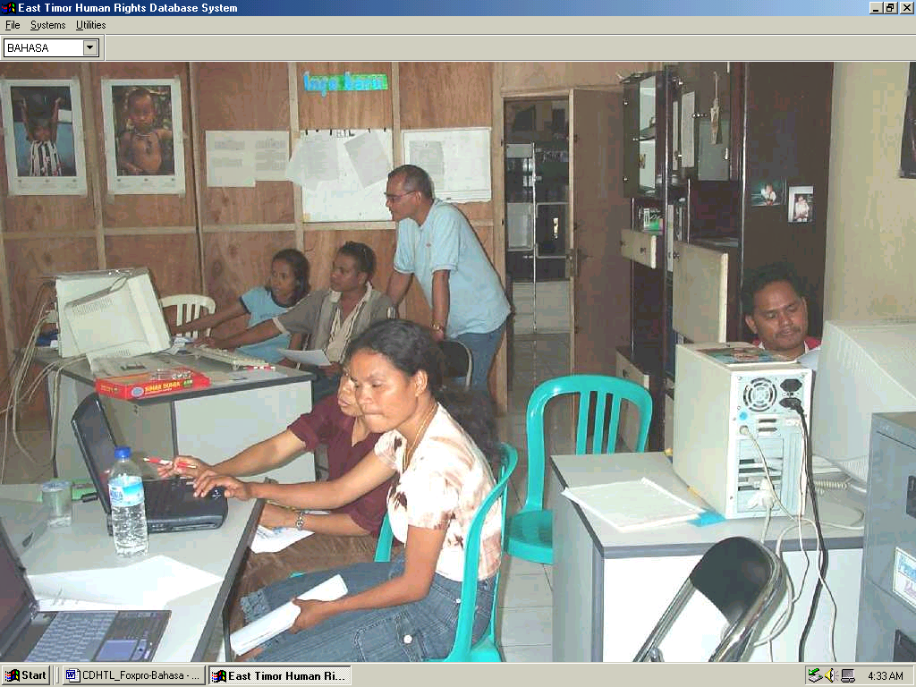
Perhatikan bahwa bahasa di-set dalam inggris, namun bisa diubah ke dalam BI.
Form pendahuluan ini akan menampilkan semua kasus dalam database, sehingga memungkinkan kita untuk menemukan suatu kejadian.

ebagai penolong, kita mempunyai berbagai tombol Sorting untuk menampilkan informasi bentuk menurut susunan abjad. Kita bisa sort per Nomor Kasus, Tanggal Kejadian, dan Lokasi.

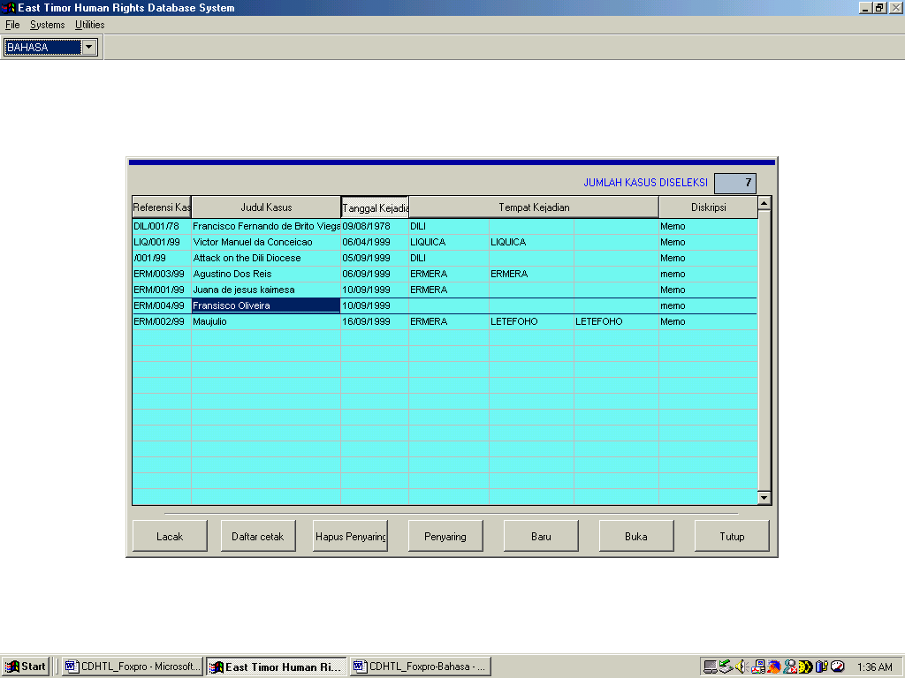
Anda bisa search kasus berdasarkan No. Kasus atau Nama Kasus. Tombol kiri memulai search dan tombol kiri akan terus jika terdapat sejumlah penemuan hasil. Jika hanya satu data, maka tombol kanan akan menampakkan String Not Found.
Kita bisa filter atau menyaring kasus berdasakan kriteria tertentu, seperti distrik, lembaga dan atau berbagai kombinasi kriteria.
Anda juga bisa print filters ini.

Perhatikan bahwa nomor kasus tidak sama dengan jumlah korban, sebab ada kasus dengan sejumlah korban.
Anda bisa print semua kasus: No. Kasus, Tgl Kejadian, Distrik, Kecamatan, Desa, Lokasi, Korban hilang, Korban, Pelaku, Lembaga. [Ingat bahwa daftar print tidak membedakan para pelaku untuk tindakan yang berbeda-beda]

Menggunakan Filter dan Print List
- Klik Filter dan bentuk berikut ini akan ditampilkan
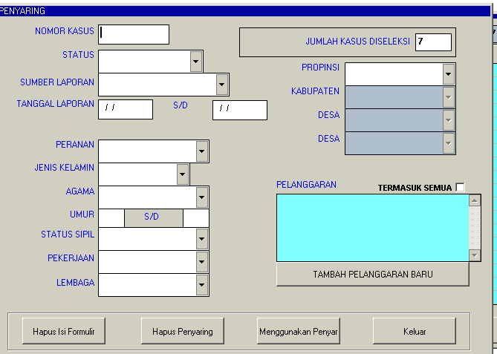

- Tulislah kriteria Anda. Misalnya, Anda menginginkan agar daftar tentang semua pelanggaran yang dilakukan oleh TNI ditampilkan
- Klik Peranan – Pelaku
Lembaga – TNI
Pelanggaran – Cek terdiri dari semua kotak
- Klik Menggunakan Penyaring
- Klik Keluar

Daftar yang disaring itu akan ditampilkan

- Klik Daftar Cetak

Menampilkan Forms
Sebelum kita belajar tentang memasukkan data kasus baru, kita akan membuka kasus yang ada:

1. Klik Kasus yang diblok, LIQ/001/99 Victor Manuel da Conceicao

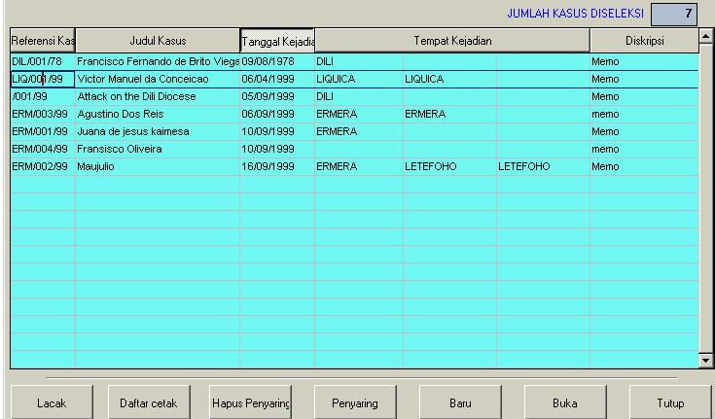

Form Kasus

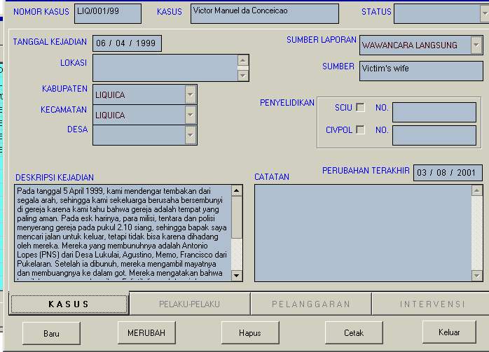

Form kasus di atas terlihat CASE Tab-nya diblok.

Form pelaku (aktor)
Pada Aktor dalam suatu kasus terdiri dari Saksi (W), Korban (V), Pelaku (P) dan Pihak Ketiga (A) (pihak ketiga adalah informasi orang atau orang-orang yang kita hendak menyimpan karena mereka terkait dengan kasus tertentu, meskipun peranan mereka tidak termasuk salah satu W, V, dan P.

Form Saksi

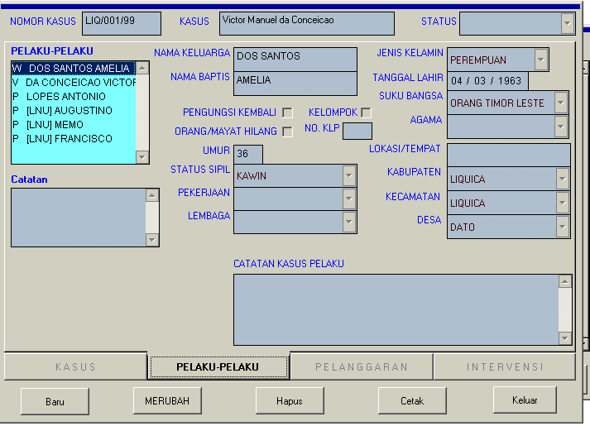

Kita memperkenalkan ide tentang suatu kasus yang sederhana yaitu yang melibatkan 1 Pelaku, 1 Pelanggaran dan 1 Korban, tetapi dalam kasus lain kita menjumpai banyak korban, banyak pelaku dan banyak pelanggaran. Misalnya,

2 Pelaku – 3 Pelanggaran – 1 Korban

Satu pelaku adalah anggota TNI yang melakukan penyiksaan dan pembunuhan terhadap seorang korban. Pelaku kedua mungkin seorang anggota milisi yang melakukan pembunuhan, tapi tidak menyiksa si korban. Kita perlu menghindari keselahan dalam arti menganggap semua orang bertanggung jawab untuk semua pelanggaran yang dilakukan oleh kedua pelaku tadi (yaitu, meletakkan tanggung jawab pada milisi sama seperti pada anggota TNI, yang melakukan penyiksaan dan pembunuhan, jika kita tahu bahwa anggota milisi tersebut tidak melakukan penyiksaan dalam kasus ini).

Jadi, bentuk-bentuk (forms) ini memberi kita cakupan untuk melihat pelanggaran berganda dan aktor ganda sehingga apabila seseorang disiksa, misalnya, diperkosa lalu dibunuh, kita tidak hanya mencatat ‘dibunuh’ dan kehilangan pelanggaran yang lain, atau kedua pelanggaran tersebut, tapi kita meletakan pelanggaran-pelanggaran itu atas pundak aktor-aktor yang benar. Jika kita hanya memasukkan jenis pelanggaran tertentu dalam database kita dan yang lain tidak, maka bahayanya ialah kita mulai menilai jenis pelanggaran misalnya ‘dibunuh’ sebagai yang paling berat sementara yang lain seperti penyiksaan tidak dianggap berat.

- Dengan meng-klik setiap aktor akan ditampilkan keterangan rinci tentang mereka sehingga Anda akan melihat berbagai perbedaan berikut

Form Korban
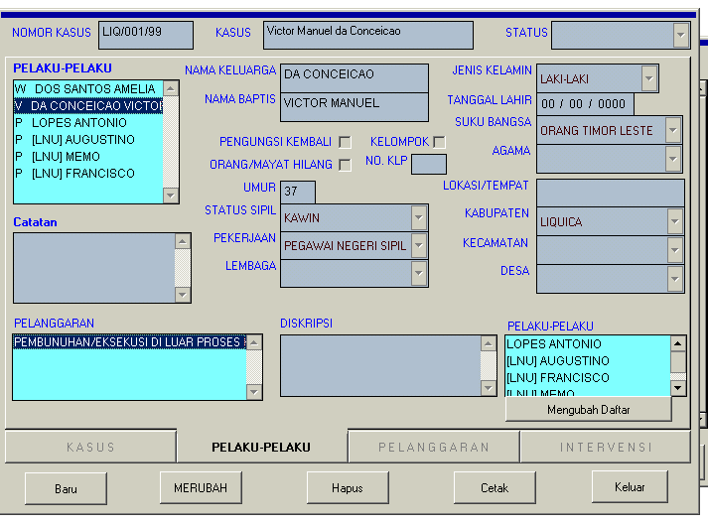
Pelanggaran-pelanggaran – didaftar
Keterangan – kotak untuk catatan tentang pelanggaran tersebut
Daftar pelaku

Form Pelaku
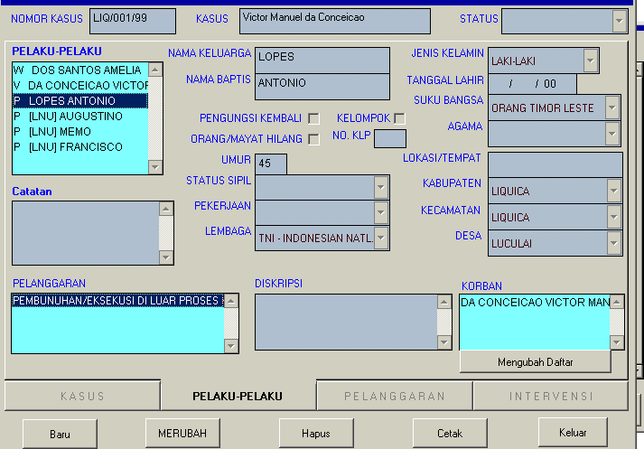
Daftar korban
Dengan menggunakan Form-Form di atas, saksi (atau para saksi) pelanggaran dan orang (atau para orang) yang melakukan pelanggaran-pelanggaran dihubungkan dengan korban (atau para korban) tersebut.
Perhatikan bahwa setiap kotak yang berwarna hijau adalah jendela ganda, yang berarti isinya bisa dibaca dalam Bahasa Indonesia.

Form pelanggaran
Ini menampilkan suatu informasi yang padat tentang informasi yang sama.
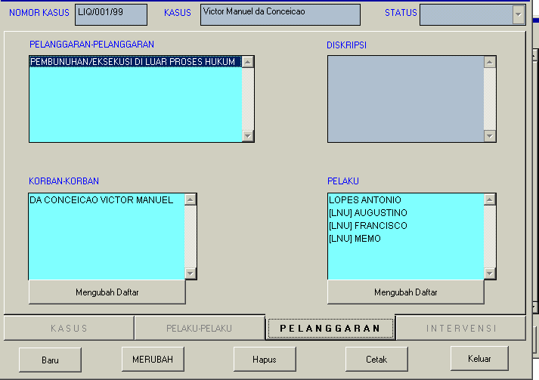

Form intervensi
Ini adalah TINDAKAN YANG TELAH DIAMBIL (yang berbeda dari TINDAKAN YANG AKAN DIAMBIL yang masuk dalam Follow-up pada Form Kasus).
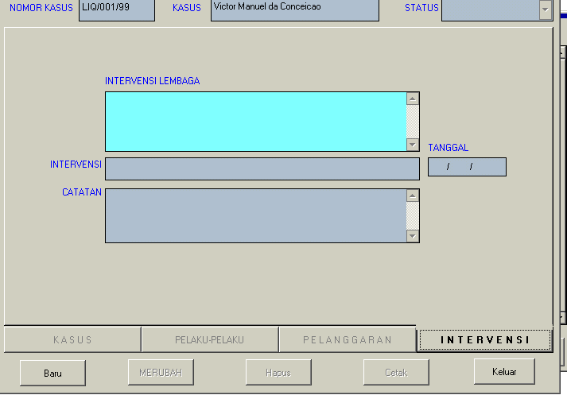
* Perhatikan bahwa Tabs ini bisa diubah atau dibuat baru tergantung dari kebutuhan Anda sendiri. Untuk perubahan tersebut silahkan menghubungi Ken Ward di Human Rights Unit.

The La’o Hamutuk Bulletin. Vol.1, No.3: 17 November 2000. http://etan.org/lh/bulletin03.html
World Health Organization. East Timor health sector situation report: January-June 2000. http://www.who.int/eha/emergenc/etimor/14082000.html
World Health Organization. Role and function of WHO in East Timor: Plan for 2001 (pamphlet). 2000.
World Health Organization. Role and function of WHO in East Timor: Plan for 2001 (pamphlet). 2000.
Martins Joao S. and Rui M de Araujo. Strategic health development planning for East Timor. (undated) http://www.ozemail.com.au/~snrt/papersheal2.html
Lihat Sri Lankan ‘Documentation Manual, Home for Human Rights’, sebagai referensi untuk karya Patrick Ball berjudul ‘Siapa Melakukan Apa Terhadap Siapa?’ Lihat juga http://hrdata.aaas.org untuk kasus-kasus yang terjadi di El Salvador, Guatemala dan Kosovo. Banyak NGO di belahan dunia lainnya yang telah menggunakan sistem serupa, terakhir di Sri Lanka dan juga dipakai oleh truth commissions di Haiti dan Afrika Selatan, dan juga oleh Misi-Misi PBB di Guatemala dan Angolas, misalnya.

